**RHEL6 to RHEL7 Migration of Physical server**

|  |  |  |  |
| --- | --- | --- | --- |
| **Date** | **Revision** | **By** | **Comment** |
| 05-10-2020 | 1.0 | D. Naresh | Initial Version |

|  |  |
| --- | --- |
| **S.No** | **Pre-checks while planning the activity** (Before raising the change) |
| 1 | Check whether subnet of the server is present in satellite 6 and cloudforms. If not available contact SMEs immediately. |
| 2 | Check whether the server has any addon from the config group server segotl1130. If the server has addon, Contact SMEs immediately. Proceed only after confirmation. |
| 3 | Check access to ILO/IDRAC and open console to test connectivity. |
| 4 | 30GB Disk should be present for ROOTVG. |
| 5 | Check TSM Backup. Execute INC backup before staring OS reinstallation. |
| 6 | Dedicated NIC to be secured for BACKUP IP. If not ask app team to raise an IPR. |
| 7 | Check puppet is syncing without any errors. (puppet agent -t). |
| 8 | Check sever is part of ITGC. If yes, please select the same in Cloudforms and add satellite parameters. |
| 9 | **Migration Facts that App Team must know**   * After reinstallation, the data in all the application filesystems and "/home" will be intact. All the content, customizations and configurations present in FS such as /root, /boot, /etc, /opt, /tmp, /var will be removed and replaced with the RHEL7 default content. * There is no /soe3 concept in RHEL7. So, the application team must make sure their application and the application scripts are compatible in RHEL7. * There should be a dedicated NIC for BACKUP IP. If not, app team must raise an ISR.   **Checklist that must be provided by Application / DB team** (if applicable)   * Necessary application local users and groups that are required. * Configuration files like /etc/services or any temporary files present in root filesystems that are needed after reinstallation. * OS parameters that should be tuned for application performance as suggested by application vendor. * Necessary application packages that are specifically needed after reinstallation. * Application user cron entries that are needed after reinstallation. * Specify the umask and ulimit value for application user if required. * Softlinks in root FS that are required to start application. * Provide other checks, if any, that are required for normal application functionality that needs to be verified by OS team before handing over the system to app team. |

**Approximate time taken for each step**

|  |  |  |  |
| --- | --- | --- | --- |
| **S.No** | **Tasks** | **Duration** | **Comments** |
| 1 | Disable monitoring (stop ITM agent) and Take basic check and Backup of all config files | 00:30 |  |
| 2 | Contact Apps team to bring down the applications | 00:30 |  |
| 3 | Do a final rsync (copy) of the application filesystems and unmount the application FS | 00:20 | will vary based on the filesystem Size |
| 4 | Sanity Reboot | 00:15 |  |
| 5 | Request H/W team to physically remove the appvg- RAID 1 disks and break the mirror of rootvg- RAID1 and attach spare/new disk to RootVG Raid. | 01:00 |  |
| 6 | Remove Puppet Certificate and retire config group | 00:05 |  |
| 7 | Create ISO image and download | 00:15 |  |
| 8 | Attach ISO image through ILO/IDRAC | 00:20 |  |
| 9 | Perform the reinstallation | 01:00 |  |
| 10 | Permit root login and login into the server | 00:05 |  |
| 11 | Change hostname and disable Firewall | 00:05 |  |
| 12 | Configure NFS and Backup IP and add static route if present earlier | 00:10 |  |
| 13 | Inform H/W team to attach the APPVG disks back. | 01:00 |  |
| 14 | Copy home directory from backup | 00:05 |  |
| 15 | Copy Host file entry and create necessary mount points | 00:10 |  |
| 16 | Add entry in fstab and mount all Filesystems | 00:10 | will vary based on number of filesystems |
| 17 | Add Swap | 00:05 |  |
| 18 | Sync Puppet Services and check add-on module implementation | 00:25 |  |
| 19 | Add Local group and users | 00:10 |  |
| 20 | Check and add old sysctl parameters | 00:05 |  |
| 21 | Configure TSM backup | 00:15 |  |
| 22 | Install security and other scanning tools like ciscat, snow agent, snapcreator | 00:05 |  |
| 23 | Application specific post checks | 00:10 | will vary based on the checks specified |
| 24 | Remap ITM situations | 00:05 |  |
| 25 | Change Boot order and reboot the server | 00:15 |  |
|  | **Total Duration** | **08:05** |  |

**Pre-Installation Steps**

1. We need 30 GB disk for rootvg in RHEL 7. If the existing RHEL 6 Machine doesn’t have one, we need to order for a new disk of 30 GB for the OS disk. The old disk should be preserved till the activity is successfully completed.
2. For RHEL 7, dedicated NIC is needed for backup IP configuration. Ensure that it is available on the server. If not, then it needs to be requested by the change coordinator.
3. Disable the monitoring.
4. Take the **basic checks for the server** before starting the activity and copy it to the jump server.
5. Save old config files that might become in handy during the POST install.

*mkdir /tmp/BACKUP*

*cd /usr/local/bin/; tar -zcvf /tmp/BACKUP/bin.tar.gz \**

*cd /usr/local/; tar -zcvf /tmp/BACKUP/local.tar.gz \**

*cd /usr/local/etc/; tar -zcvf /tmp/BACKUP/userlocaletc.tar.gz \**

*cd /soe3/; tar -zcvf /tmp/BACKUP/soe3.tar.gz \**

*cd /var/spool/cron; tar -cvf /tmp/BACKUP/cron.tar \**

*cd /opt/;tar -zcvf /tmp/BACKUP/opt.tar.gz \**

*cd /etc/ssh/; tar -zcvf /tmp/BACKUP/ssh.tar.gz \**

*cd /etc; tar -cvf /tmp/BACKUP/cron_d.tar cron.\**

*cd /etc; tar -cvf /tmp/BACKUP/etc_init.d.tar \**

*cp -p /etc/modprobe.conf /tmp/BACKUP/*

*cp -p /etc/sysctl.conf /tmp/BACKUP/*

*cp -rp /etc/security/limits* /tmp/BACKUP/*

*cp -p /etc/passwd /tmp/BACKUP/*

*cp -p /etc/shadow /tmp/BACKUP/*

*cp -p /etc/group /tmp/BACKUP/*

*cp -p /etc/services /tmp/BACKUP/*

*cp -p /etc/fstab /tmp/BACKUP/*

*cp -p /etc/sysconfig/network-scripts/ifcfg-* /tmp/BACKUP/*

*cp -p /etc/sysconfig/network-scripts/route* /tmp/BACKUP/*

*cp -p /etc/motd /tmp/BACKUP/*

*cp -p /etc/hosts /tmp/BACKUP/*

*cp -p /etc/security/access.conf /tmp/BACKUP/*

*cp -p /etc/resolv.conf /tmp/BACKUP/*

*cp -p /etc/auto* /tmp/BACKUP/*

*cp -p /etc/sudoers /tmp/BACKUP/*

*cp -p /etc/redhat-release /tmp/BACKUP/*

*cp -p /etc/rsyslog.conf /tmp/BACKUP/*

*cp -p /etc/multipath.conf /tmp/BACKUP*

*pvs > /tmp/BACKUP/pvs.txt*

*vgs > /tmp/BACKUP/vgs.txt*

*lvs -a -o +devices > /tmp/BACKUP/lvs.txt*

*ifconfig > /tmp/BACKUP/ifconfig.txt*

*df -hP > /tmp/BACKUP/df.txt*

*mount > /tmp/BACKUP/mount.txt*

*sestatus > /tmp/BACKUP/selinux.txt*

*rpm -qa > /tmp/BACKUP/rpmlist.txt*

*service --status-all > /tmp/BACKUP/runningservices.txt*

*free -g > /tmp/BACKUP/free.txt*

*ip route > /tmp/BACKUP/iproute.txt*

*date > /tmp/BACKUP/date.txt*

*df -hP | tr -s " " |cut -d " " -f6|sed 1d|xargs ls -ld > /tmp/BACKUP/FS-permission.txt*

*df -hP | tr -s " " |cut -d " " -f6|sed 1d|xargs ls -l > /tmp/BACKUP/FS-permission-level1.txt*

*yum list all > /tmp/BACKUP/yum-list.txt*

*yum repolist > /tmp/BACKUP/yum-repolist.txt*

*facter > /tmp/BACKUP/facter-puppet.txt*

*sysctl -a > /tmp/BACKUP/sysctl-a.txt*

*ip addr show > /tmp/BACKUP/ipaddr.txt*

*lsblk -i > /tmp/BACKUP/lsblk-op.txt*

Find TSM config file and take Backup

*cp -p /opt/tsmcfg/nodes/<server-name>/etc/dsm.sys /tmp/BACKUP/*

1. Create tarball and copy to an external source.

*cd /tmp/  
tar -zcvf /tmp/<server-name>.tar.gz BACKUP*

From jump server,

*scp a262237@<server-name>:/tarball/file-name/ <home-dir>*

1. If this is an Oracle DB server take backup of **/etc/soe4oracle/** and **/etc/oratab**.
2. Take backup of home directory **/home** in any application filesystem and restore after activity.
3. Take backup of **/soe3** in any application filesystem. Restore soe3 only if application team asks specifically. If not don’t restore.
4. Take a backup of this server’s configuration file present in hiera server.
5. Make a note of the application FS permission and ownership.
6. Take the application team provided checks.
7. Check whether any of the below tools installed in the server using below command and make sure to install them after reinstallation.

* For cis-cat

*rpm -qa |grep -i ciscat*

* For csp

*/etc/init.d/sisidsagent status*

*rpm -qa |grep -i sdcss*

* For ILMT bigfix

*rpm -qa |grep -i BESAgent*

*/etc/init.d/besclient status*

* For qradar

*grep 153.112.91.70 /etc/rsyslog.conf*

* For Snapcreator,

*rpm -qa |grep -i snapcreator*

/etc/init.d/scAgent status

* For snowagent,

*rpm -qa |grep -i snowagent*

1. Get in touch with the application contact to bring down the apps.
2. If **“scenario 2”** is followed in the “**Application data Scenarios”** section, this is the time to do the final rsync.
3. Do a sanity reboot of the server and make sure application is stopped by checking with app team again.
4. Unmount all application FS.
5. Ask Hardware team to remove the APPVG disks physically and break the mirror of ROOTVG disk.

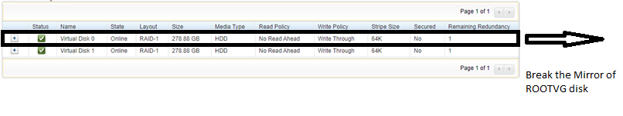

* attach the new disk to rootvg Raid. ( Virtual Disk 0)

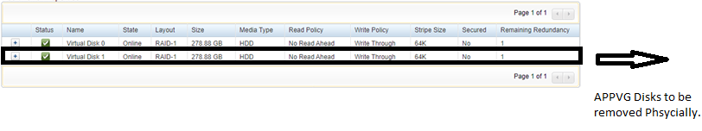

* APP VG disks (Virtual Disk 1 group) to be attached back as its once OS reinstallation completed.

1. Check for the puppet certificate for the server on **segotl1225**.

*puppet cert list <FQDN>*

*Eg: puppet cert list segotl3472-n1.srv.volvo.com*

1. If certificate exists, then remove it using the below command.

*puppet cert clean <FQDN>*

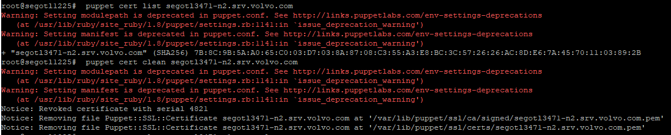

1. Check for config group of the server on segotl1130 and retire it if it exists.

*/usr/local/bin/configgroup-manager.bash hostname=<host-name> --list (make a note of this output)*

*/usr/local/bin/configgroup-manager.bash hostname=<host-name> --retire*

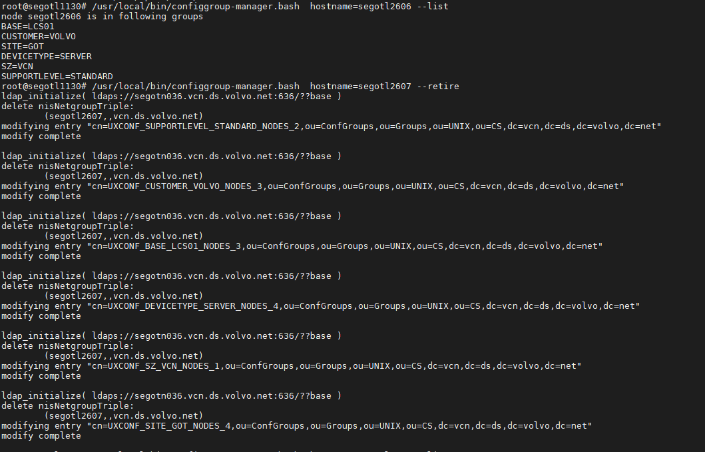

**Reinstallation**

1. Login into cloudforms

<https://segotl2789.it.volvo.com/ui/service/login>

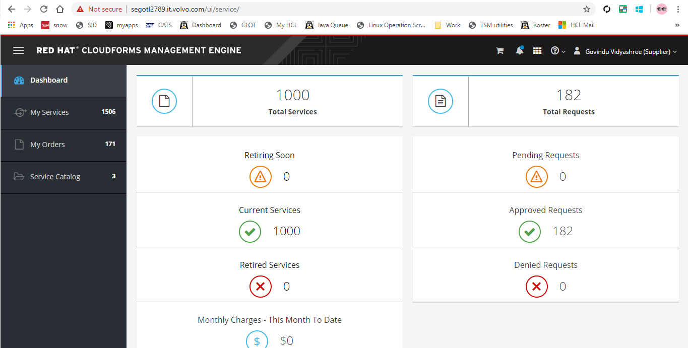

1. Select, **service catalog --> lcs.**

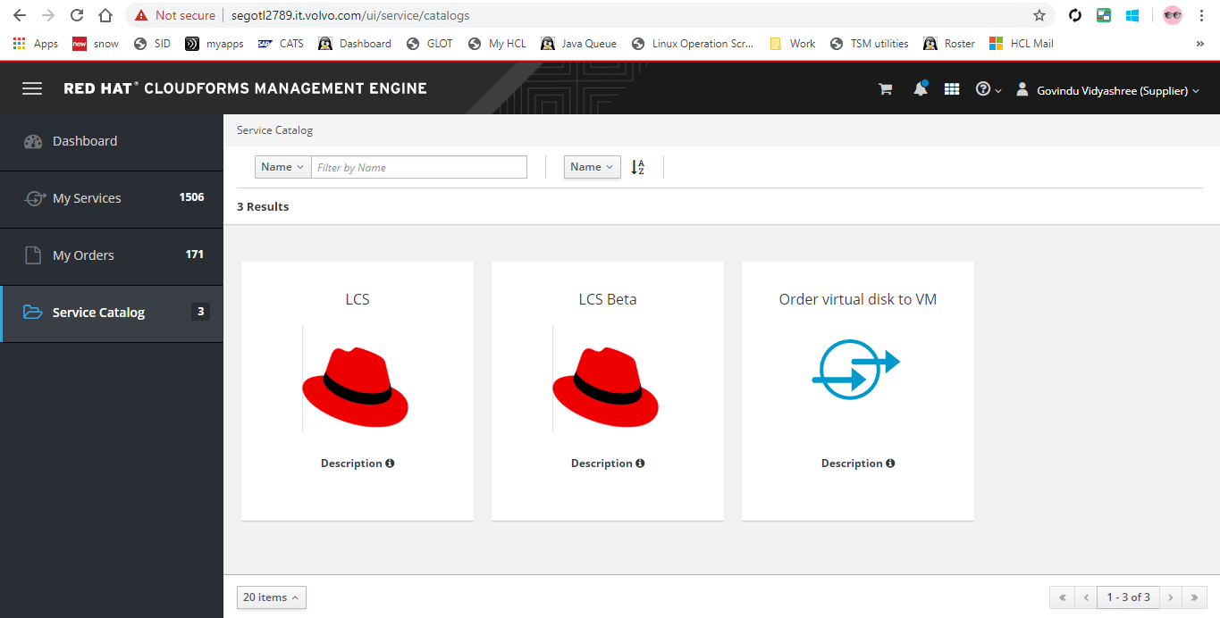

1. Fill the requested details.

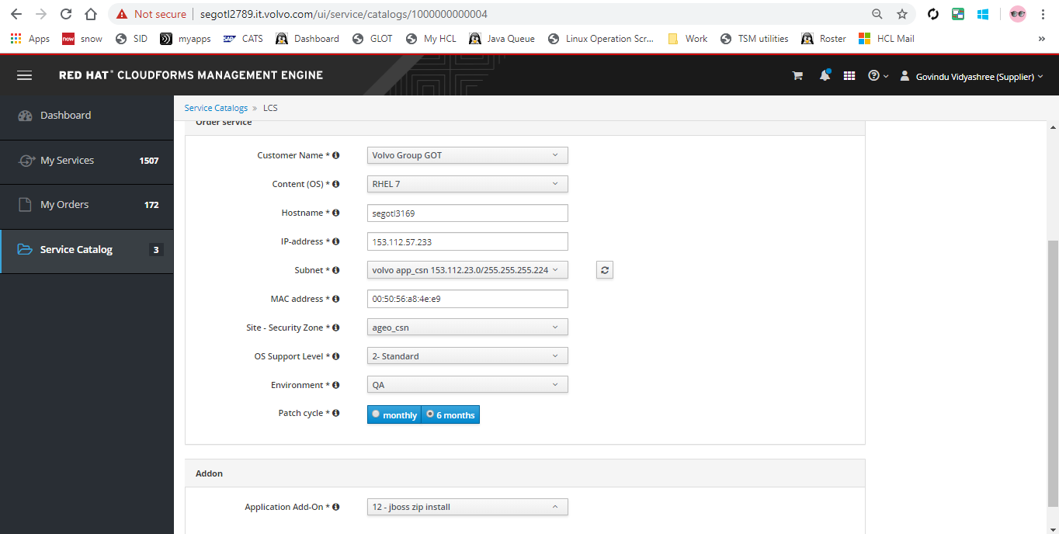

1. Click add to cart at the top right corner and order the server.

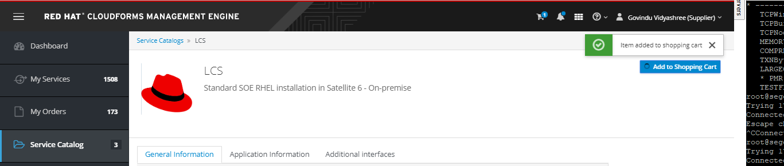

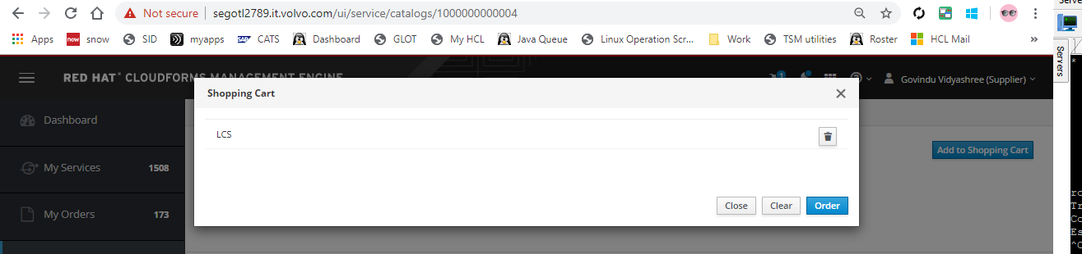

1. Go to “My Orders” and check for the order status. It will be finished immediately.

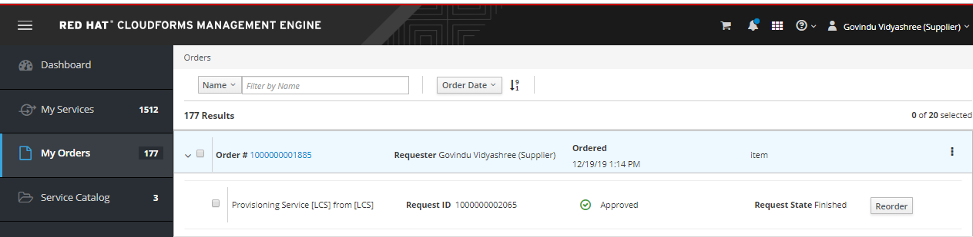

1. Login into satellite 6

<https://segotl2596.srv.volvo.com/>

1. Select, **Hosts --> All hosts**

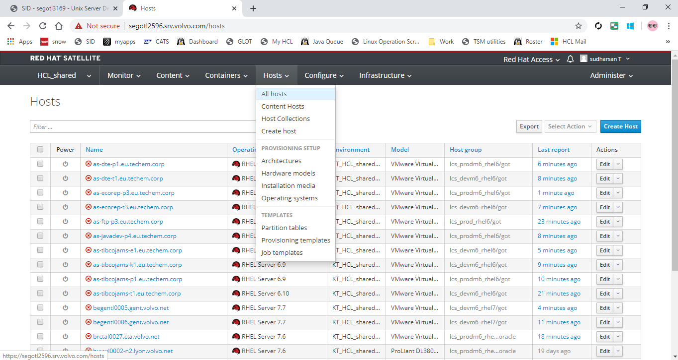

1. search server name and click on server name.

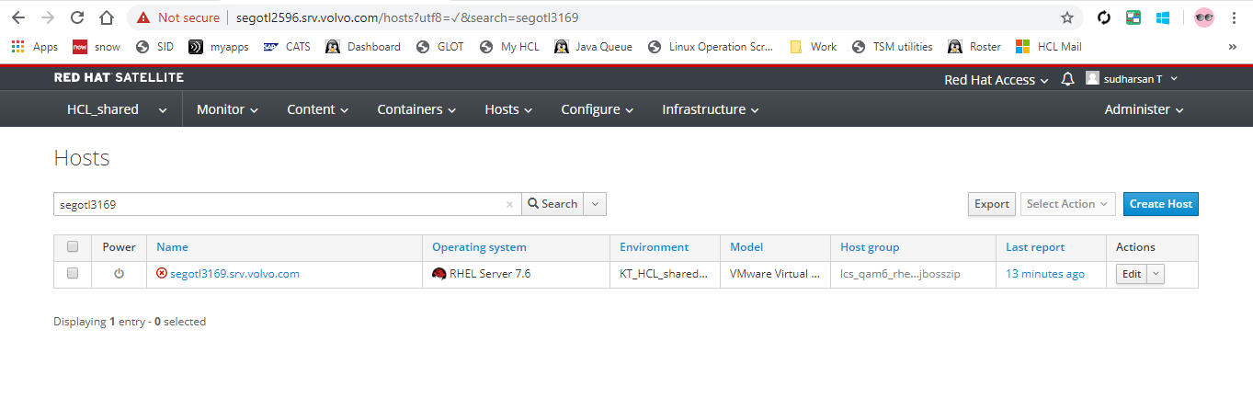

1. select, **Boot disk --> Host 'segotl3169' image**. It will download an iso image.

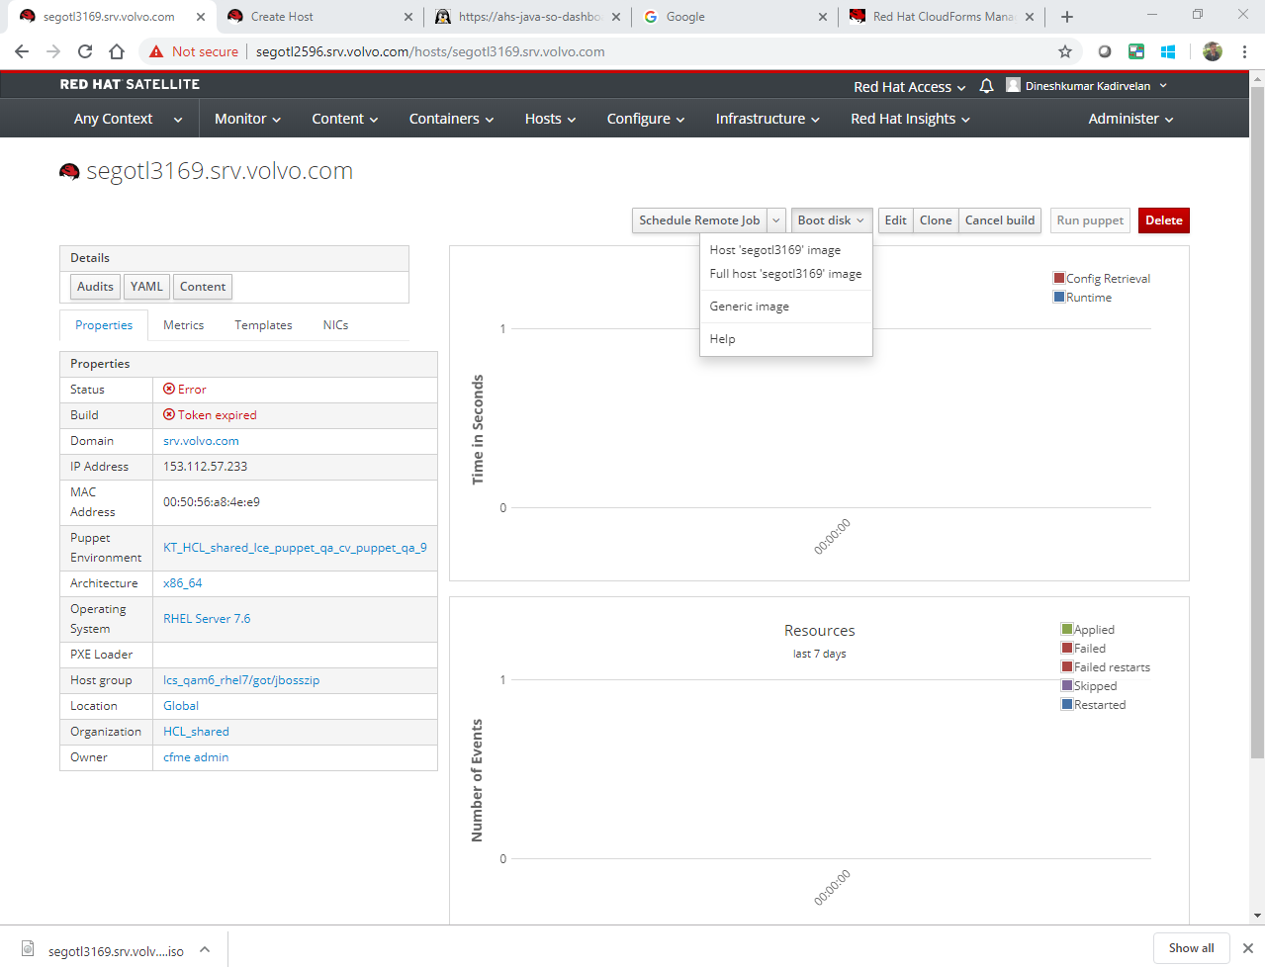

1. Login to IDRAC.

Click Setup -> Change First Boot Device to Virtual CD/DVD/ISO.

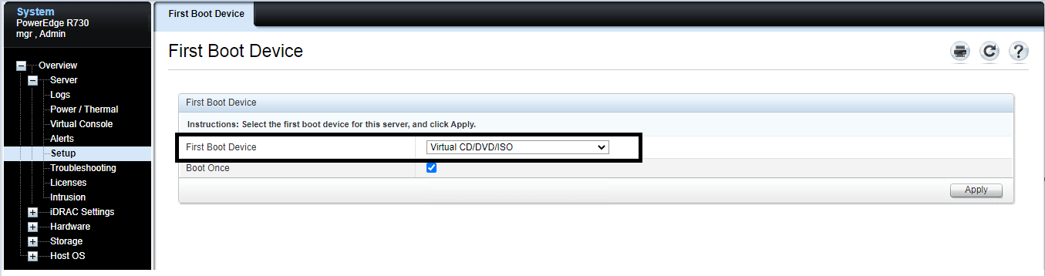

1. Take **ILO/IDRAC Console** and attach the iso.

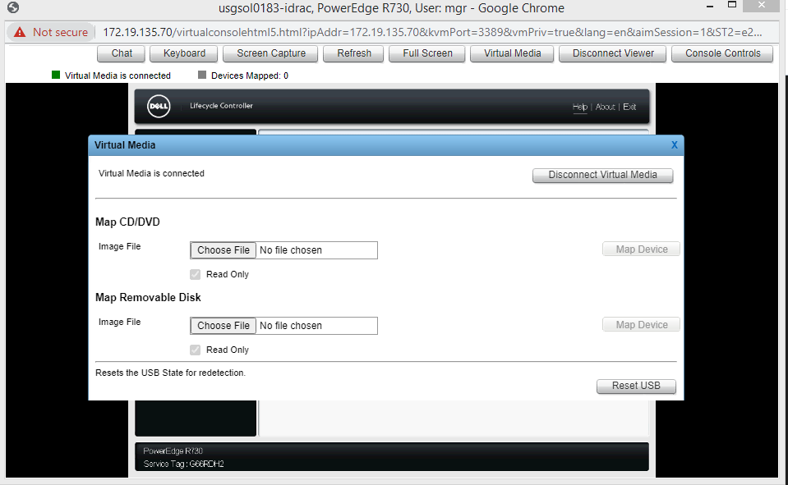

Click-> choose the image file.

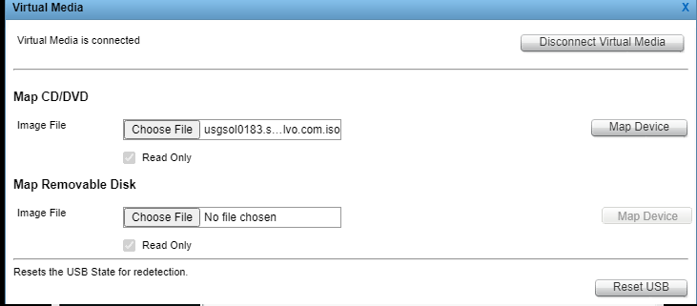

Click Map Device

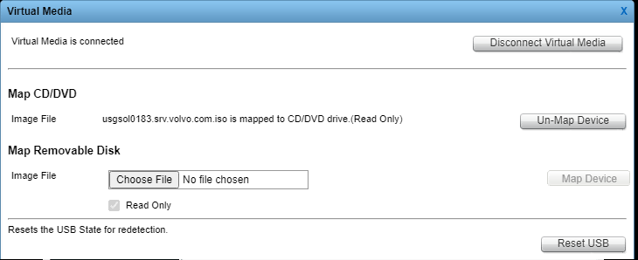

1. Restart the Server
2. Installation will start with the details in the ISO image as below.

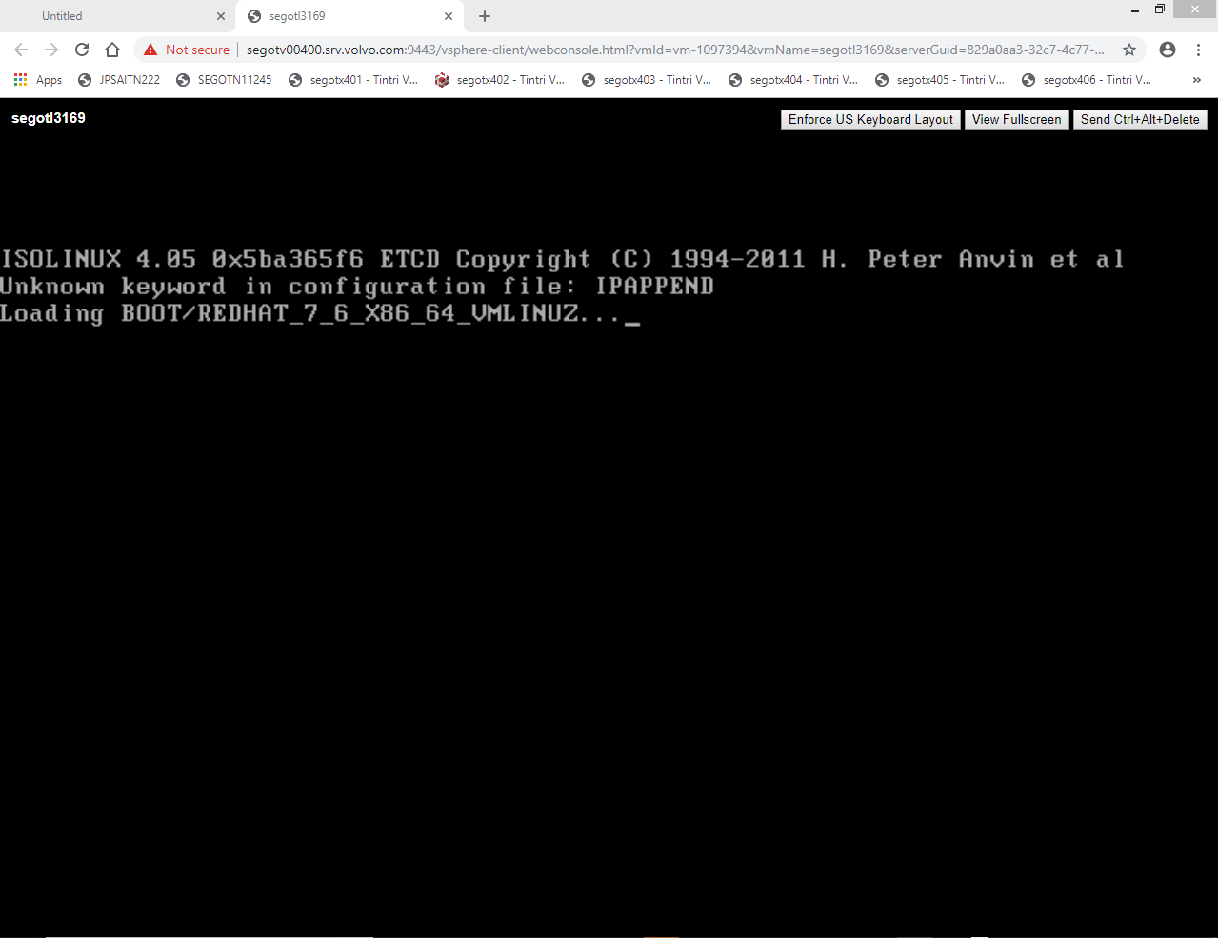

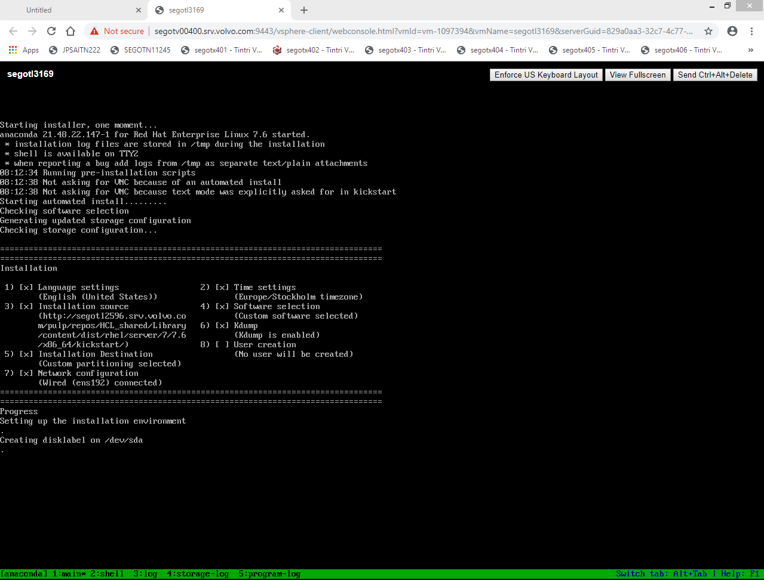

**Filesystem creation**

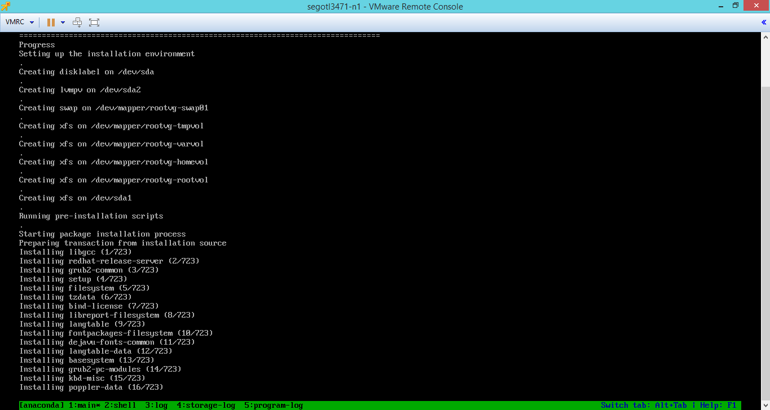

**Package Installation**

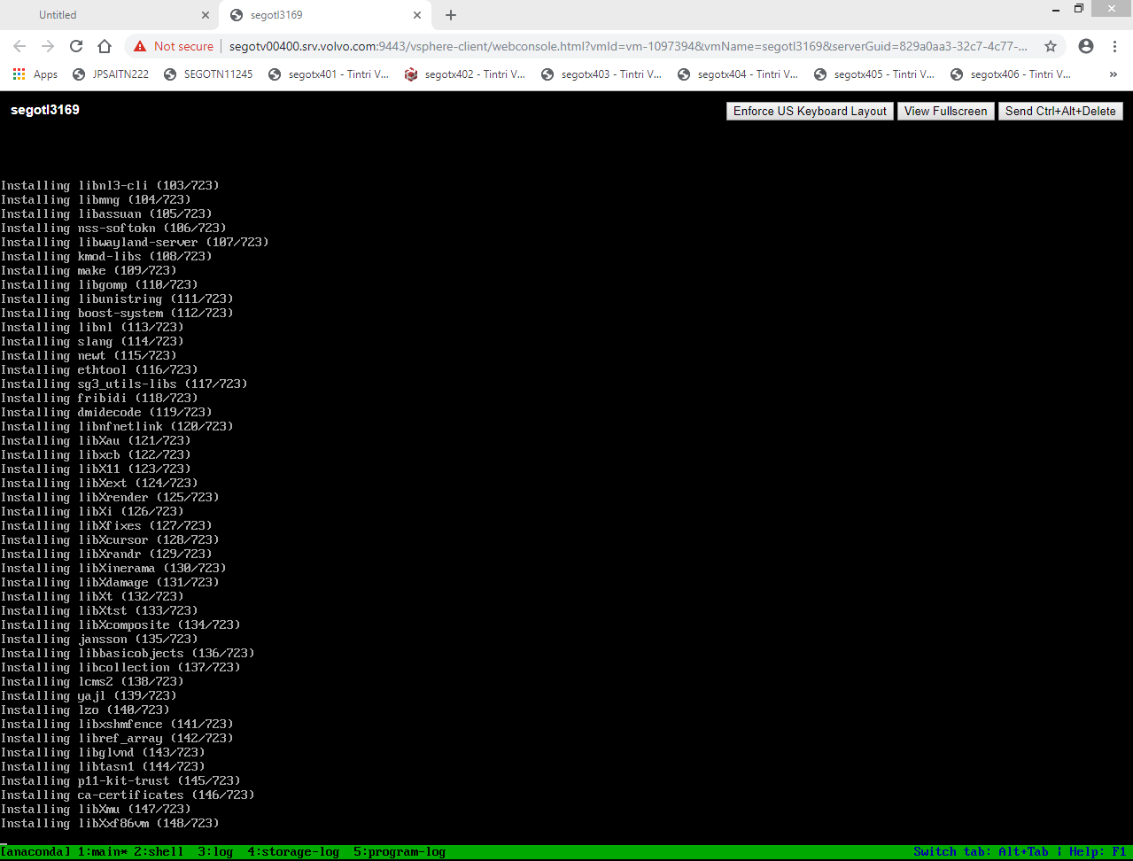

**Installation Complete**

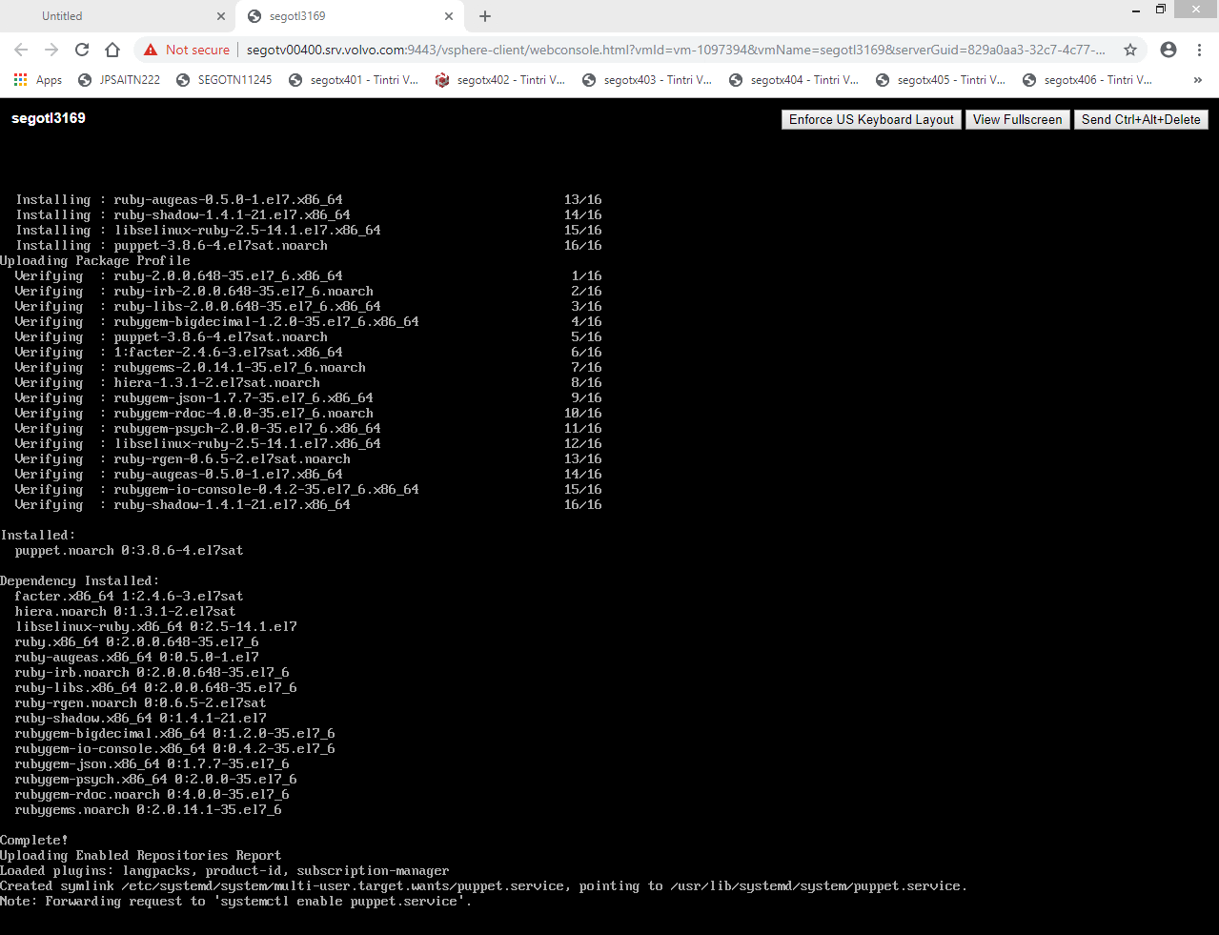

1. Server will Reboot after Installation.

**Post-Installation Steps**

1. Login with the default root password **DoBe42L8.** If not working change the Root password using below steps.

*• Boot into the kernel. In the line which has linux 16, type* ***rd.break*** *at the last,*

*Linux16 ………….*

*………………………. rd.break*

and press ctrl+x to load further.

*• Run below commands as needed.*

*mount //Check /sysroot mounted as rw, if not mount as rw*

*mount -o remount,rw /sysroot*

*chroot /sysroot //OS will be loaded from the iso image run this to move into root FS in the server*

*passwd*

*touch /.autorelabel //will restore the default selinux context for this filesystem and important step*

*exit*

*exit*

1. Permit root login by modifying **PermitRootLogin** parameter in the file **/etc/ssh/sshd_config** as below**.** Login as root via putty.



1. Verify hostname of the server. It should be **segotlxxx** or **srvxxxx.** If the hostname is set as FQDN, it must be changed using below command.

*hostnamectl set-hostname <server-name>*

*ex: hostnamectl set-hostname srv33838*

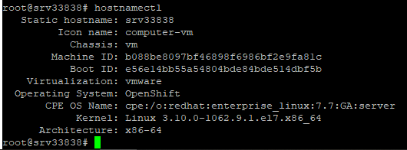

1. Timezone should be same before and after the activity. Check and verify the Timezone from “date.txt” file and change if required.
2. Stop and disable firewalld service.

*# systemctl stop firewalld.service*

*# systemctl disable firewalld.service*

1. Copy the backup tar ball file created during precheck, to the root directory of the server and preserve it for any future reference.
2. Configure NFS IP and Backup IP using below command.

nmcli con add con-name <interface-name> ifname <interface-name> type 802-3-ethernet ip4 <ip/prefix>

Eg: nmcli con add con-name "ens224" ifname ens224 type 802-3-ethernet ip4 172.18.86.151/17

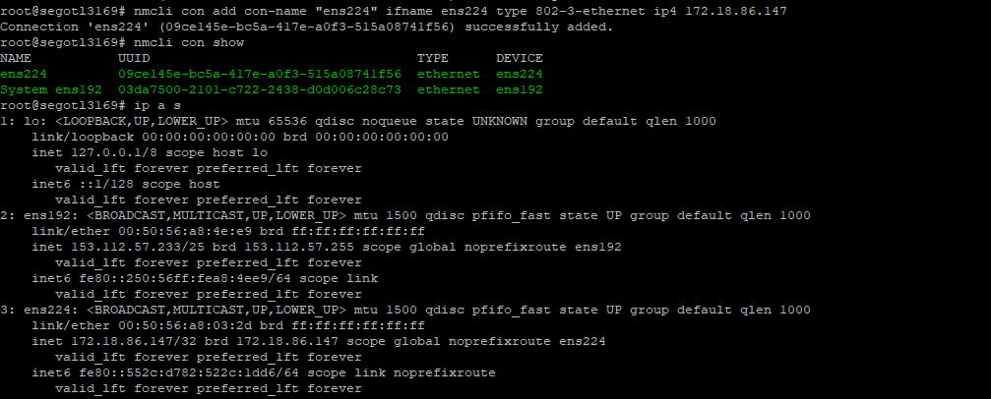

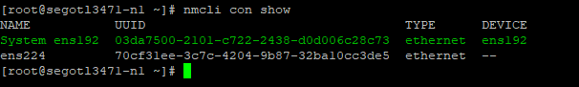



1. Check for any static route in old backup file “**iproute.txt**” and add them.

*ip route add <network-range> via <gateway/IP> dev <interface-name>*

*Ex: ip route add 172.23.106.0/23 via 172.23.26.1 dev ens224*

1. Create an entry in below file to make the routing permanent.

*/etc/sysconfig/network-scripts/route-<interface-name>*



1. Inform H/W team to attach the application disk.
2. Restore multipath conf file
3. Copy entries to /etc/hosts from hosts file in backup.
4. Restore old /etc/services file. Do this only if the application team mentioned this in check list or requests for the file.
5. Refer “**Application Data Scenarios**” section for the scenarios.

* For “**Scenario 1”** all the required FS will be created by automatically when puppet is synced.
* For “**Scenario 2**”
  + The xfs filesystems will be detected immediately once the disks are attached from VMware end.
  + This can be verified by using vgs and lvs commands.
  + If the server has add-on, rename the volume group to the old name or as per the add-on requirement.
  + Only when the disk, volume group, mounpoints and Filesystems are as per the add-on requirement, puppet will sync properly.
  + Create the necessary mountpoints and mount the filesystems.
* For “**Scenario 3**”
* The ext4 FS will be detected immediately once the disks are attached from VMware end.
* We need to create new XFS File systems for application data as the existing setup.
* For this get new disks of the same size as the existing application disks from VMteam and create new VG, LV and XFS Filesystem.
* Mount the new XFS filesystem in temporary mountpoint and copy (rsync) data from the existing ext4 File systems.
* Once rsync is completed and verified, unmount the existing ext4 filesystems and mount the new XFS filesystem in the respective mountpoints.

1. Copy application FS entries from old fstab file. Create the necessary mountpoints and mount the NFS Filesystems.

Double check all the filesystems, NFS shares and their sizes.

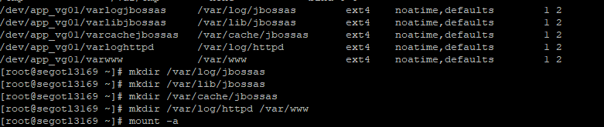

1. Restore the **/home** dir from backup.
2. Check swap in old server output and add swap as required. Make entry in fstab file.

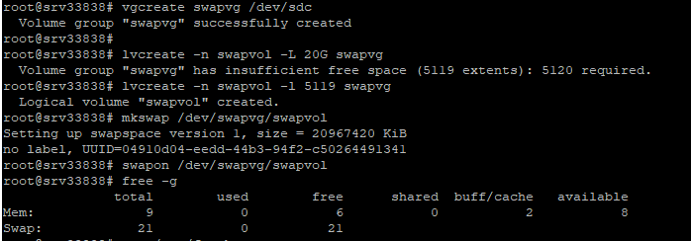

1. Sync puppet service. Satellite 6 server is integrated to the puppet master. So, no need to sign certificates.

# puppet agent -t

1. If the server has add-on, puppet will sync properly only when the disk, volume group, moutpoint and Filesystems are as per the add-on requirement. If not, it will throw error. Check and fix it before proceeding.
2. Puppet will sync sudoers file and other config files.
3. **Sync puppet again. It should sync without any errors. If you get any error don’t proceed further. Proceed only after fixing puppet error.**
4. Check and Create the necessary local users and groups that are provided by the app / DB team. Use the same UID and GID as mentioned in the backup files. Also verify the entries in ***/etc/passwd, /etc/group, /etc/shadow***.

Never restore ***/etc/passwd, /etc/group, /etc/shadow*** files from RHEL 6. It will break the system. Only add the necessary users.

1. Check and make sure the entries of these local users in **access.conf** are same as the entry in old file.
2. Check and add **cron** entries.
3. Check and add **sysctl** parameters.
4. Test connection with the TSM server. Contact backup team for password to connect with TSM server. (This is not applicable for H&M servers). Kindly stop tsm temporarily. We can enable after application validation.
5. Make sure server hostname is like “segotlxxxx” and not the FQDN. If hostname is FQDN, server will not be registered in tsm server. (This is not applicable for H&M servers)
6. Install below tools if they are present before reinstallation.

* For cis-cat

*rpm -qa |grep -i ciscat*

* For csp

*/etc/init.d/sisidsagent status*

*rpm -qa |grep -i sdcss*

* For ILMT bigfix

*rpm -qa |grep -i BESAgent*

*/etc/init.d/besclient status*

* For qradar

*grep 153.112.91.70 /etc/rsyslog.conf*

* For Snapcreator,

*rpm -qa |grep -i snapcreator*

/etc/init.d/scAgent status

* For snowagent,

For SJ server, copy the package **/unixadmins/SJ_snowagent-5.2.0-1.x86_64.rpm** from **segotl0836** to the SJ server under /tmp and run the below command.

*rpm -ivh /tmp/SJ_snowagent-5.2.0-1.x86_64.rpm*

1. Detach the ISO image clicking connect-virtual media and unmap Device.
2. Verify the check list provided by application team. Restore application config files, create softlinks and other checks that are mentioned by the app team in their check list.
3. Sent email to “Raja Govindarajulu [rajagovin@hcl.com](mailto:rajagovin@hcl.com)” asking to remove the /soe3 form clopset.
4. Inform application team to start application and validate the application status.